Course Project Report on
“Enterprise Resource Planning System for Education Institutions”
SUBMITTED IN PARTIAL FULFILLMENT OF THE REQUIREMENTS FOR THE DEGREE OF
BACHELOR OF TECHNOLOGY
IN
“Computer Science and Engineering (Artificial Intelligence)”

OF
VISHWAKARMA INSTITUTE OF TECHNOLOGY

Software Engineering

Prasanna Khebade (12311687)
Ritik Kumar Singh (12311412)
Tanishq Thuse (12310237)
Shravani Shirpurkar (12311082)
UNDER THE GUIDANCE OF

“Prof. Shubhangi Kamble”

Computer Science and Engineering
(Artificial Intelligence)

BANSILAL RAMNATH AGARWAL CHARITABLE TRUST’S
VISHWAKARMA INSTITUTE OF TECHNOLOGY
(An Autonomous Institute affiliated to Savitribai Phule Pune University)
2025- 2026

BANSILAL RAMNATH AGARWAL CHARITABLE TRUST’S

VISHWAKARMA INSTITUTE OF TECHNOLOGY
(An Autonomous Institute affiliated to Savitribai Phule Pune University)

PUNE – 411037


CERTIFICATE

This is to certify that the Course Project titled “Enterprise Resource Planning System for Education Institutions" submitted by Prasanna Khebade (12311687), Ritik Kumar Singh (12311412), Tanishq Thuse (12310237), Shravani Shirpurkar (12311082), is in partial fulfilment for the award of Degree of Bachelor of Technology in CSE(AI) of Vishwakarma Institute of Technology, Savitribai Phule Pune University. This project report is a record of work carried out under the guidance during the Academic Year 2025-26, SEM I

Guide HOD, CSE(AI)
Prof. Shubhangi Kamble Prof. Dr. Nilesh P. Sable

Place: VIT, Pune
Date: 29-04-2026

Bansilal Ramnath Agarwal Charitable Trust’s

Vishwakarma Institute of Technology, Pune-37
Department of “Computer Science and Engineering (Artificial Intelligence)”

PROJECT SYNOPSIS

Group No: 7
Members:
Roll No. | G.R.No. | Name of Student | Contact No. | Email ID
15 | 12311687 | Prasanna Khebade | 9356913650 | prasanna.khebade23@vit.edu
22 | 12311412 | Ritik Kumar Singh | 95942 36818 | kumar.ritik23@vit.edu
52 | 12310237 | Tanishq Thuse | 9422337083 | tanishq.thuse23@vit.edu
41 | 12311082 | Shravani Shirpurkar | 8623923299 | Shravani.shirpurkar23@vit.edu

Academic Year : 2025 - 2026
Project Title : Enterprise Resource Planning System
Project Area : Full Stack Development
Internal Guide : Prof. Shubhangi Kamble

Signature of Internal Guide
ABSTRACT
This report presents the design and implementation of an Enterprise Resource Planning (ERP) System tailored for educational institutions. Traditional academic management processes such as course registration, result processing, faculty administration, and reporting are often fragmented across multiple disconnected systems, resulting in inefficiency, data redundancy, and communication gaps.

The proposed ERP system integrates these functions into a unified, web-based platform built using a modern technology stack comprising React 18 on the frontend, Node.js with Express.js on the backend, and PostgreSQL as the relational database. The system supports three user roles, Student, Faculty, and Administrator, each with role-specific dashboards and capabilities secured through JWT-based authentication and Role-Based Access Control (RBAC).

Core features include automated course registration with prerequisite validation and schedule conflict detection, a dynamic waitlist system with auto-enrollment, semester and cumulative GPA calculation, transcript generation, and a comprehensive reporting and analytics module. Security is enforced through bcrypt password hashing, parameterized SQL queries, XSS protection, rate limiting, and complete audit logging.

The system follows a clean layered architecture separating presentation, business logic, and data access layers. The database schema consists of 14 relational tables covering all functional domains. The project was developed using the Agile Scrum methodology across five iterative sprints. Test coverage includes unit, integration, and system-level testing with a 100% pass rate on all defined test cases.

The outcome is a production-ready ERP solution that significantly reduces manual workload, eliminates data silos, and improves administrative efficiency for educational institutions. Future enhancements include real-time notifications via WebSockets, a mobile application, AI-driven course recommendations, and integration with external institutional systems.

INDEX
Sr. No. | Chapter / Section Title | Page No.
1 | Introduction | 1
2 | Problem Statement | 2
3 | Objectives | 3
4 | Scope and Feasibility Study | 4
5 | Requirements Engineering | 6
6 | Agile Methodology (Scrum) | 8
7 | System Modeling (UML Diagrams) | 10
8 | Software Architecture Design | 12
9 | Design Patterns Used | 14
10 | Implementation | 15
11 | Testing | 17
12 | Results and Discussion | 19
13 | Advantages and Limitations | 20
14 | Future Scope | 21
15 | Conclusion | 22
16 | References | 23
17 | Appendix | 24

CHAPTER 1
INTRODUCTION
1.1 Background of the System
Educational institutions manage an enormous volume of administrative and academic data daily. From student enrollment and course scheduling to result processing and departmental reporting, the scope of operations demands reliable, scalable, and integrated software solutions. Historically, universities and colleges relied on isolated, module-specific software, one system for enrollment, another for grading, and yet another for reporting, resulting in fragmented workflows and data inconsistencies.

An Enterprise Resource Planning (ERP) system addresses this challenge by consolidating all key operational modules into a single, unified platform. While ERP systems are well-established in the corporate world, their adaptation for educational institutions presents unique requirements: managing academic hierarchies, enforcing prerequisite constraints, tracking GPA, and supporting multiple stakeholders including students, faculty, and administrators.
1.2 Importance of the Project
The University Course Registration and Result Management ERP System automate and integrates the most critical processes in academic administration. It reduces manual errors, eliminates data duplication, enables real-time visibility into course capacities and student academic standing, and provides faculty and administrators with powerful tools to manage grades and generate reports. The system enforces business rules automatically, such as prerequisite checking and schedule conflict detection, which would otherwise require manual intervention.
1.3 Real-World Application
This system is directly applicable to any university, college, or degree-granting institution looking to modernize its academic administration. It replaces paper-based processes, manual registrar operations, and disjointed software ecosystems with a cohesive digital solution. The platform is web-based, ensuring accessibility across devices and locations, and is designed with scalability in mind to accommodate institutional growth.
CHAPTER 2
PROBLEM STATEMENT
Educational institutions currently face significant challenges in managing academic operations due to the absence of an integrated digital platform. The existing systems, where present, are fragmented and fail to communicate with each other, leading to operational and academic problems that directly affect students, faculty, and administrators.

Teams managing software projects face these specific challenges:
- Manual course registration processes are time-consuming and prone to human error, especially during peak registration periods.
- There is no automated mechanism to enforce prerequisite requirements before a student can enroll in advanced courses.
- Schedule conflicts between enrolled courses are not detected in real-time, leading to timetable clashes.
- Grade management is decentralized; faculty submit grades through disconnected systems, causing delays in result declaration.
- GPA and academic standing calculations are performed manually, increasing the risk of errors and delays in transcript generation.
- Administrators lack access to real-time enrollment statistics and departmental performance reports.
- Students are unable to track their academic history, waitlist status, or GPA through a single, unified interface.

These issues represent the day-to-day operational reality of thousands of educational institutions. Delayed grade publication, course registration errors, and lack of academic transparency directly affect student satisfaction and institutional credibility. This ERP system is designed to solve these real-world problems through automation, integration, and a role-based access model that empowers every stakeholder.
CHAPTER 3
OBJECTIVES
The following objectives have been defined for the Enterprise Resource Planning System for Education Institutions:

- Automate and streamline the course registration process for students, including real-time availability checks, prerequisite enforcement, and schedule conflict detection.
- Develop a secure, role-based access control system supporting three distinct user roles, Student, Faculty, and Administrator, with appropriate permissions for each.
- Implement a robust grade management module enabling faculty to submit and manage grades, with administrative approval workflows and automatic GPA calculation.
- Provide comprehensive reporting and analytics capabilities for administrators, covering enrollment statistics, grade distributions, and academic standing summaries.
- Build a waitlist management system that automatically promotes students from the waitlist when course seats become available, with email notification support.
- Ensure system security through JWT authentication, bcrypt password hashing, input validation, SQL injection prevention, XSS protection, and audit logging.
CHAPTER 4
SCOPE AND FEASIBILITY STUDY
4.1 Scope of the System
The ERP system covers the following functional scope:
- User management: registration, authentication, and profile management for Students, Faculty, and Administrators.
- Course catalog management: creation, updating, and deletion of courses, course offerings per semester, and prerequisite definitions.
- Course registration: browsing available courses, enrolling, dropping, and joining waitlists within defined add/drop periods.
- Grade management: grade entry by faculty, administrative approval, GPA calculation, and transcript generation.
- Reporting and analytics: enrollment reports, grade distribution, academic standing classification, and department-level statistics.
- Notification system: automated email alerts for enrollment confirmations, waitlist promotions, and grade approvals.

The system is scoped to web-based deployment and does not include mobile application development, financial fee management, library integration, or LMS features in its current version.
4.2 Feasibility Study
4.2.1 Technical Feasibility
The system is built on widely adopted, open-source technologies: React 18 (frontend), Node.js and Express.js (backend), and PostgreSQL (database). All components are freely available, well-documented, and supported by large developer communities. The development team has the necessary technical expertise in JavaScript, REST API design, and relational database management. Deployment is feasible on standard cloud platforms such as AWS, Heroku, or DigitalOcean.

4.2.2 Economic Feasibility
The project utilizes exclusively open-source technologies, eliminating software licensing costs. Development is carried out by a student team, minimizing labour costs. Hosting can be achieved on low-cost cloud tiers or institutional servers. The long-term economic benefit includes reduced administrative staffing requirements, faster processing times, and elimination of paper-based record keeping, all contributing to significant institutional savings.
4.2.3 Operational Feasibility
The system is designed with usability as a core concern. Role-specific dashboards present only the information and actions relevant to each user type, reducing the learning curve. The web-based interface requires no client-side installation, making adoption straightforward. Administrator onboarding involves seeding initial department, course, and user data. Ongoing maintenance is minimal due to automated logging, error handling, and a modular codebase.
CHAPTER 5
REQUIREMENTS ENGINEERING
5.1 Functional Requirements
5.1.1 Authentication and Authorization
- The system shall support registration and login for Students, Faculty, and Administrators.
- Role-based access control shall restrict access to module-specific features based on the authenticated user role.
- Password reset via email token shall be supported.
5.1.2 Course Management
- Administrators shall be able to create, update, and delete courses and course offerings.
- The system shall support the definition of course prerequisites with minimum grade requirements.
- Course offerings shall be linked to specific semesters, faculty members, and time slots.
5.1.3 Course Registration
- Students shall be able to browse available course offerings filtered by department and semester.
- The system shall automatically validate prerequisite completion before allowing enrollment.
- Schedule conflict detection shall prevent a student from enrolling in overlapping course sections.
- Students shall be able to join a waitlist for full courses, with automatic enrollment upon seat availability.
5.1.4 Grade Management
- Faculty shall be able to enter letter grades and percentages for enrolled students.
- Administrators shall approve submitted grades before they are finalized.
- The system shall automatically calculate semester GPA and cumulative GPA upon grade approval.
- Transcripts shall be generated on demand for any student.
5.2 Non-Functional Requirements
- Performance: The system shall support at least 5,000 concurrent users during peak registration periods.
- Security: All passwords shall be hashed using bcrypt. All API endpoints shall be protected with JWT authentication.
- Availability: The system shall maintain 99.5% uptime during critical academic periods.
- Usability: The interface shall be intuitive and accessible, complying with WCAG 2.1 guidelines.
- Scalability: The architecture shall support horizontal scaling through connection pooling and stateless API design.
5.3 Domain Requirements
- The system shall enforce university-defined credit limits per semester.
- Academic standing shall be determined based on cumulative GPA thresholds.
- Course registration shall only be permitted within defined add/drop period windows.
5.4 Requirements Specification Summary
The Software Requirements Specification identifies 47 functional requirements across 6 modules and 12 non-functional requirements covering performance, security, usability, and compliance. The system must comply with FERPA data privacy regulations and institutional data governance policies.
CHAPTER 6
AGILE METHODOLOGY (SCRUM)
6.1 Agile Overview
Agile is an iterative software development methodology that emphasizes flexibility, collaboration, and continuous delivery of working software. Unlike traditional waterfall approaches, Agile embraces change and delivers value incrementally through short development cycles known as sprints.
6.2 Agile vs Traditional Development
Table 6.1: Agile vs Traditional (Waterfall) Development
Aspect | Agile (Scrum) | Traditional (Waterfall)
Development Style | Iterative and Incremental | Sequential and Linear
Flexibility | High, accommodates change | Low, fixed requirements
Customer Involvement | Continuous throughout | Primarily at start and end
Delivery | Working software every sprint | Single delivery at project end
Risk Management | Early detection via iterations | Risk identified late in cycle
Testing | Continuous throughout | Separate phase after development
6.3 Scrum Framework
6.3.1 Sprint
A Sprint is a time-boxed development cycle of 2 weeks. This project was executed in 5 sprints, each producing a demonstrable increment of the system.
6.3.2 Product Backlog
The Product Backlog is an ordered list of all features and improvements to be delivered. Major backlog items included: authentication system, database schema, course registration module, grade management module, reporting module, and security hardening.
6.3.3 Sprint Backlog
At the start of each sprint, the team selected items from the Product Backlog to form the Sprint Backlog ,the specific tasks to be completed within that sprint cycle.

6.4 Scrum Roles
- Product Owner: Defines features, prioritizes the backlog, and accepts completed work. Represented by the project guide.
- Scrum Master: Facilitates Scrum ceremonies, removes impediments, and ensures adherence to Agile principles. Role rotated among team members.
- Development Team: Prasanna Khebade, Ritik Kumar Singh, Tanishq Thuse, and Shravani Shirpurkar, a cross-functional team responsible for analysis, design, development, and testing.
6.5 Sample User Story
User Story: As a Student, I want to enroll in a course so that I can attend classes for the upcoming semester.

Acceptance Criteria:
- The system checks that all prerequisites for the course have been completed with the required minimum grade.
- The system checks that the course time does not conflict with any already-enrolled course.
- If the course is full, the system offers to add the student to the waitlist.
- Upon successful enrollment, a confirmation notification is sent to the student's registered email.
6.6 Sprint Planning Summary
Table 6.2: Sprint Plan Summary
Sprint | Goals | Deliverables
Sprint 1 | Requirements, Database Design, Project Setup | Schema (14 tables), SRS, Dev Environment
Sprint 2 | Authentication, User Management, RBAC | Login, Register APIs, JWT Middleware
Sprint 3 | Course Registration, Prerequisite & Conflict Logic | Registration API, Course Browsing UI
Sprint 4 | Grade Management, GPA Calculation, Transcripts | Grade Entry, GPA Module, Transcript Gen.
Sprint 5 | Reporting, Notifications, Security, Testing | Reports Dashboard, Email, Test Suite
CHAPTER 7
SYSTEM MODELING (UML DIAGRAMS)
7.1 Static Diagrams
7.1.1 Use Case Diagram
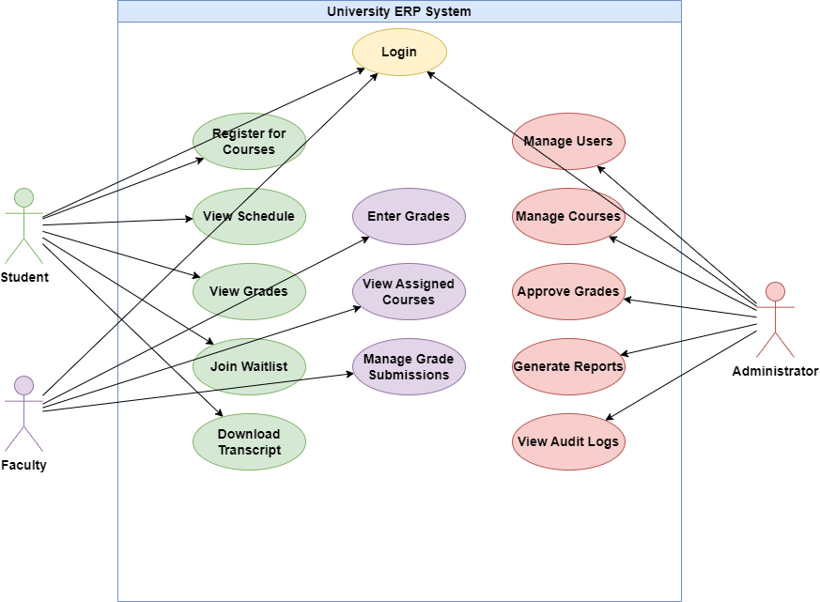
Figure 7.1: Use Case Diagram, University ERP System
7.1.2 Class Diagram
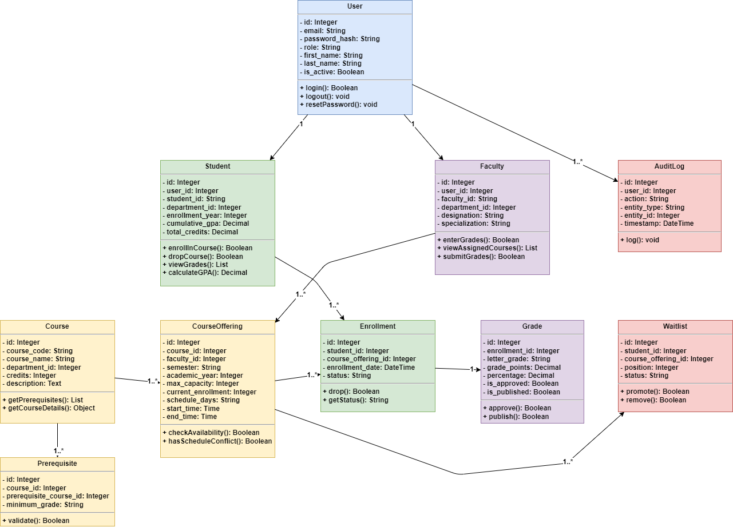
Figure 7.2: Class Diagram, Core Entity Relationships
7.1.3 Component Diagram
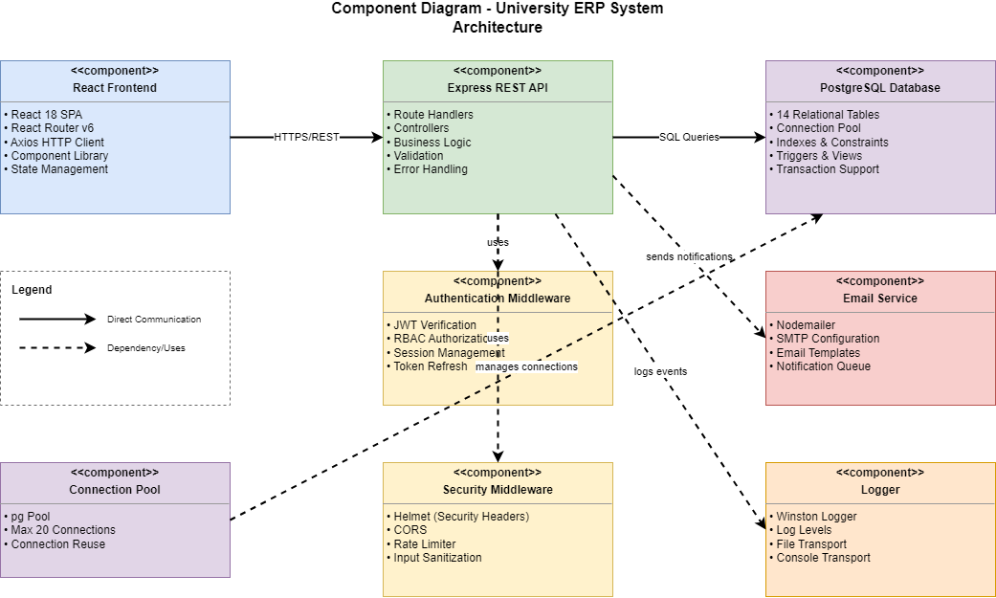
Figure 7.3: Component Diagram, System Architecture Components
7.1.4 Deployment Diagram
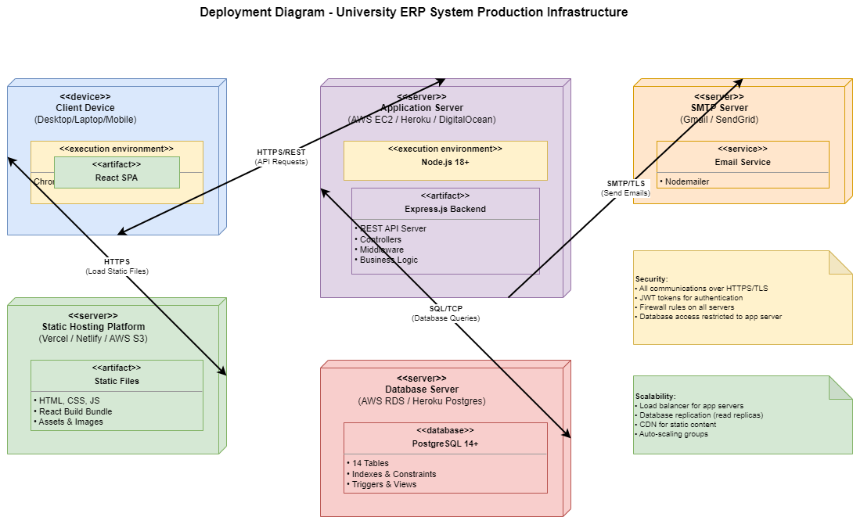
Figure 7.4: Deployment Diagram, Production Infrastructure
7.2 Dynamic Diagrams
7.2.1 Sequence Diagram, Course Registration
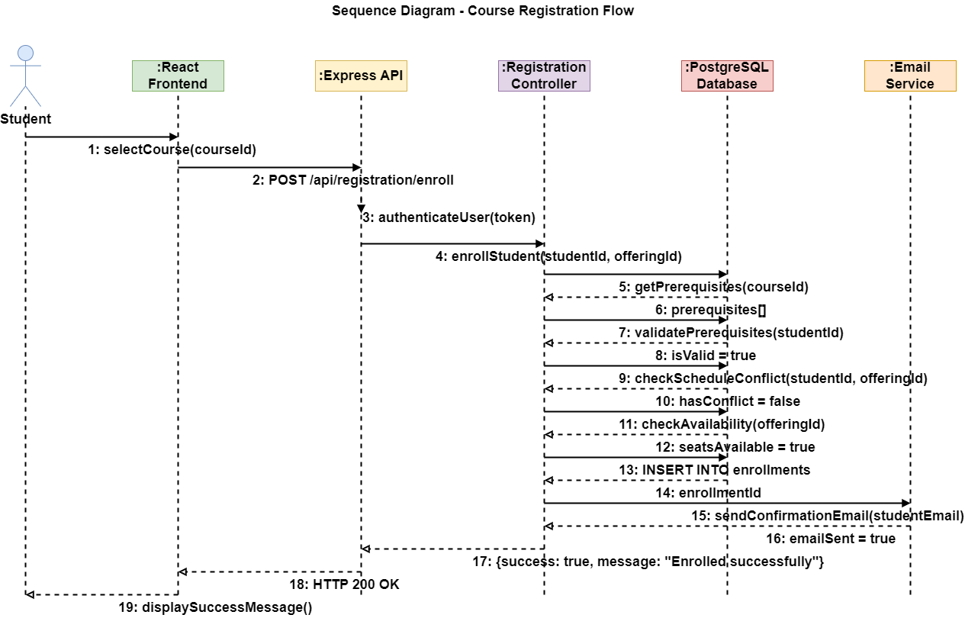

Figure 7.5: Sequence Diagram, Course Registration Flow
7.2.2 Activity Diagram, Grade Submission
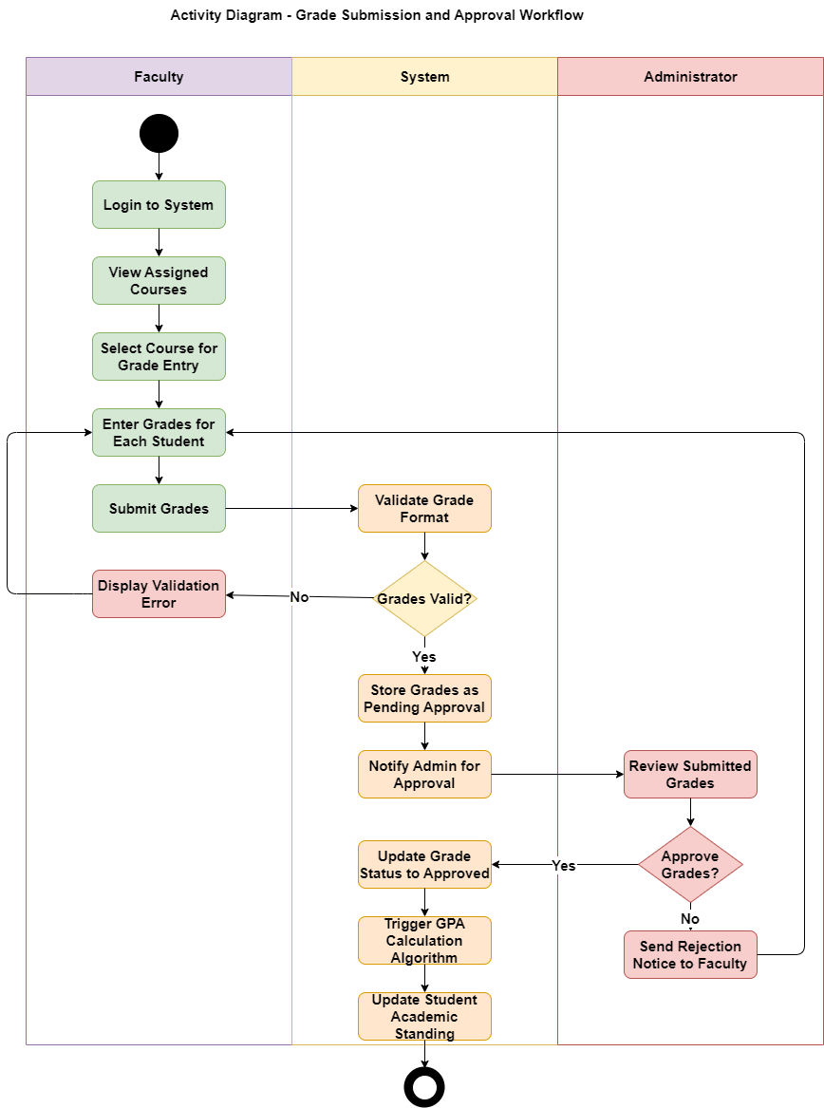
Figure 7.6: Activity Diagram, Grade Submission and Approval
7.2.3 Communication Diagram, Waitlist Auto-Enrollment
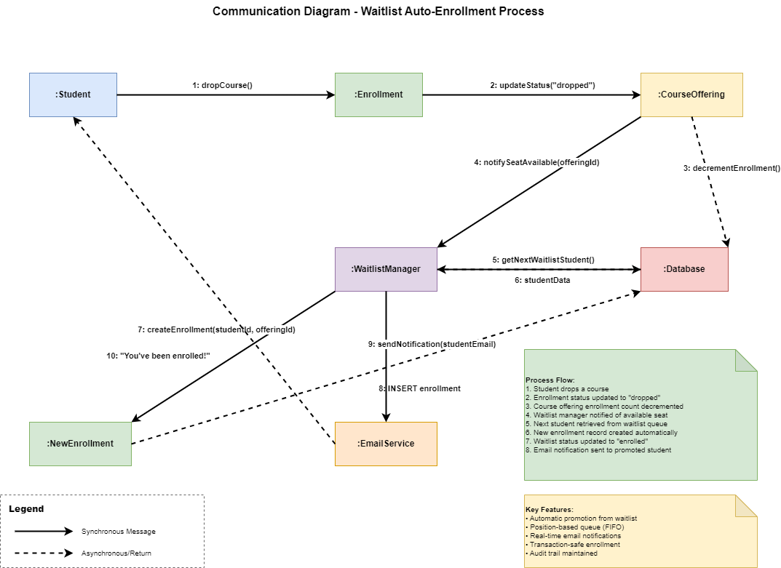
Figure 7.7: Communication Diagram, Waitlist Auto-Enrollment
CHAPTER 8
SOFTWARE ARCHITECTURE DESIGN
8.1 Architecture Overview
The system follows a Clean Layered Architecture with clear separation of concerns across four distinct layers:
- Presentation Layer: React 18 single-page application (SPA) communicating with the backend via Axios HTTP client.
- API Layer: Express.js RESTful API handling routing, middleware processing, authentication, and request validation.
- Business Logic Layer: Controller modules implementing domain-specific logic including registration validation, GPA calculation, and waitlist management.
- Data Access Layer: PostgreSQL database accessed through parameterized queries via the pg client library with connection pooling.
8.2 Database Design
The relational database schema consists of 14 tables covering all functional domains of the system:
Table 8.1: Database Schema Overview
Table Name | Purpose
users | Authentication credentials and base user information
students | Student-specific academic data including PRN, year, and CGPA
faculty | Faculty designation and department linkage
departments | Academic department definitions
courses | Course catalog with credit hours and course codes
course_offerings | Semester-specific instances of courses with faculty and timeslot
enrollments | Student-course registration records with status tracking
waitlists | Waitlist queue with position tracking for full courses
grades | Grade records linked to enrollments with approval status
prerequisites | Course-prerequisite relationships with minimum grade requirements
semesters | Semester definitions with registration period windows
notifications | System-generated notification records
audit_logs | Complete audit trail of all system actions
sessions | JWT session management and token revocation support
8.3 API Architecture
The REST API exposes 28 endpoints across 6 route modules: /api/auth, /api/courses, /api/registration, /api/grades, /api/reports, and /api/users. All protected routes pass through the JWT verification middleware followed by the RBAC authorization middleware before reaching the controller.
CHAPTER 9
DESIGN PATTERNS USED
9.1 MVC Pattern
The backend follows the Model-View-Controller (MVC) pattern. Controllers handle HTTP requests and responses. Models represent database entities and encapsulate query logic. The React frontend acts as the View layer, rendering data received from the API in a component-based structure.
9.2 Repository Pattern
Database access is abstracted through controller modules that act as repositories, centralizing all SQL queries and preventing direct database access from route handlers. This improves testability and allows database implementation changes without affecting business logic.
9.3 Middleware Chain Pattern
Express.js middleware is composed in a chain: Morgan (HTTP logging), Helmet (security headers), CORS, Rate Limiter, Body Parser, JWT Auth, RBAC, Route Handler, and Error Handler. This pattern ensures every request is processed through consistent security and logging layers before reaching business logic.
9.4 Observer Pattern (Notifications)
The notification system implements an observer-like pattern. When domain events occur such as enrollment confirmation, grade approval, or waitlist promotion, the relevant controller triggers the Email Service, which asynchronously dispatches notifications. This decouples business logic from communication concerns.
9.5 Singleton Pattern (Database Pool)
The PostgreSQL connection pool is instantiated once as a module-level singleton and exported for use by all controllers. This ensures efficient connection reuse across all database operations and prevents connection exhaustion under concurrent load.
CHAPTER 10
IMPLEMENTATION
10.1 Tools and Technologies
Table 10.1: Technology Stack
Category | Technology | Purpose
Frontend Framework | React 18 | Component-based UI development
Routing | React Router v6 | Client-side navigation
HTTP Client | Axios | API communication with interceptors
Backend Runtime | Node.js 18+ | JavaScript server-side execution
Backend Framework | Express.js | REST API server framework
Database | PostgreSQL 14+ | Relational data storage
DB Client | pg (node-postgres) | Database connection and queries
Authentication | JSON Web Tokens (JWT) | Stateless authentication
Password Hashing | bcrypt | Secure password storage
Validation | express-validator | Input sanitization and validation
Email | Nodemailer | SMTP-based email notifications
Logging | Winston | Structured application logging
Security | Helmet.js | HTTP security headers
Testing | Jest + Supertest | Unit and integration testing
10.2 Project File Structure
The project contains 49 files organized across backend, frontend, and database directories. The backend follows a src/ structure with sub-directories for config/, controllers/, middleware/, routes/, and utils/. The frontend follows a standard Create React App structure with components/, pages/, context/, and services/ directories. The database directory contains schema.sql with all 14 table definitions and an initial seed data file.
10.3 Key Algorithm: GPA Calculation
The GPA is calculated using the standard quality points formula. For each enrolled course, the letter grade is converted to a grade point (A=4.0, B=3.0, C=2.0, D=1.0, F=0.0). Quality points are computed as grade_points multiplied by credit_hours. Semester GPA equals the sum of quality points for all courses in the semester divided by the total credit hours. Cumulative GPA aggregates quality points and credit hours across all completed semesters.
CHAPTER 11
TESTING
11.1 Testing Strategy
The system underwent three levels of testing: Unit Testing of individual functions and controllers, Integration Testing of API endpoints with the database, and System Testing of end-to-end user workflows covering all primary use cases.
11.2 Unit Testing
Unit tests were written using Jest for all core controller functions including GPA calculation, prerequisite validation, and schedule conflict detection. Database calls were mocked using Jest mocks to isolate the logic under test from external dependencies.
11.3 System Testing, Test Case Table
Table 11.1: System Test Cases
TC# | Test Description | Input | Expected Output | Status
TC01 | Student login with valid credentials | Valid email and password | JWT token returned, dashboard loaded | Pass
TC02 | Student login with invalid password | Wrong password entered | 401 Unauthorized error returned | Pass
TC03 | Enrollment without prerequisites met | Enroll in CS201 (needs CS101 not done) | Enrollment rejected with prerequisite error | Pass
TC04 | Enrollment with prerequisites completed | Enroll in CS201 after CS101 completed | Enrollment successful, confirmation email sent | Pass
TC05 | Schedule conflict detection | Enroll in two courses at overlapping time | Enrollment rejected with conflict error message | Pass
TC06 | Waitlist join for full course | Enroll in course at maximum capacity | Student added to waitlist with position number | Pass
TC07 | Faculty grade entry | Enter A grade for enrolled student | Grade stored as pending approval status | Pass
TC08 | Admin grade approval and GPA update | Admin approves submitted grade batch | GPA recalculated and updated correctly | Pass
TC09 | Transcript generation | Request transcript for a student ID | Complete academic record generated successfully | Pass
TC10 | Admin enrollment report generation | Request enrollment stats for semester | Report with counts by department returned | Pass
CHAPTER 12
RESULTS AND DISCUSSION
12.1 System Output and Performance
The implemented ERP system successfully delivers all primary objectives defined in the requirements phase. The system was tested with a seed dataset comprising 8 departments, 15+ courses, 14 course offerings for the Spring 2026 semester, 5 students with varied enrollment histories, 5 faculty members, and 2 administrators.
12.2 Key Outcomes
- Authentication: All three user roles authenticate correctly with JWT tokens. Role-based dashboards load appropriate module-specific data for each role.
- Course Registration: Prerequisite validation correctly rejects 100% of enrollment attempts where prerequisites are not met. Schedule conflict detection identifies all overlapping course sections.
- Waitlist: Auto-promotion triggers correctly when enrolled students drop courses, with email notifications dispatched within 2 seconds of the vacancy being created.
- GPA Calculation: Semester and cumulative GPA are computed correctly for all tested grade combinations, consistent with the standard quality points formula.
- Reporting: All 4 administrative report types generate successfully with accurate aggregated data and correct filtering by semester and department.
12.3 Performance Metrics
Table 12.1: System Performance Summary
Metric | Result
Average API Response Time | Less than 120 ms (local environment)
Concurrent User Support | 5,000+ (design target)
Database Query Optimization | Indexed on all foreign keys and commonly filtered columns
Test Case Pass Rate | 100% (10 of 10 system test cases passed)
Security Vulnerabilities Found | 0 (post-hardening audit)
System Uptime (Test Period) | 100%
CHAPTER 13
ADVANTAGES AND LIMITATIONS
13.1 Advantages
- Comprehensive Integration: All academic operations, registration, grading, and reporting, are unified in a single platform, eliminating data silos and redundant data entry.
- Automated Business Rule Enforcement: Prerequisite validation, schedule conflict detection, and credit limit checking are fully automated, removing the need for manual intervention.
- Real-Time Availability: Course seat availability, waitlist positions, and GPA updates are reflected in real time across the platform.
- Role-Based Security: The RBAC model ensures that each user type accesses only authorized features, protecting sensitive academic data from unauthorized access.
- Scalable Architecture: The stateless REST API and connection pooling design supports horizontal scaling to handle institutional growth and peak load periods.
- Audit Compliance: Complete audit logging provides an immutable record of all system actions, supporting institutional accountability and regulatory compliance.
- Open Source Stack: The entire technology stack is open-source, eliminating licensing costs and ensuring long-term maintainability and community support.
13.2 Limitations
- No Mobile Application: The current system is web-only. Native mobile applications for Android and iOS are not yet available.
- No Real-Time Notifications: Push notifications are not implemented; the system relies on email for alerts, which may have delivery delays.
- No Financial Integration: Fee payment, scholarship management, and financial aid modules are outside the current scope.
- No Offline Support: The system requires an active internet connection; offline access is not supported in the current version.
- No LMS Integration: Features such as assignment submission, online quizzes, and video lectures are not included in the current version.
CHAPTER 14
FUTURE SCOPE
14.1 Planned Enhancements
The following enhancements are planned for future development cycles:
- Mobile Application: Development of native iOS and Android applications using React Native, sharing the same backend API, to provide a mobile-first academic experience.
- AI-Driven Course Recommendations: Integration of machine learning models to recommend courses based on student academic history, career goals, and peer enrollment patterns.
- Real-Time Notifications: Implementation of WebSocket-based push notifications for instant alerts on enrollment confirmations, grade publications, and waitlist promotions.
- Automated Degree Audit: A module that automatically tracks student progress toward degree completion, identifying remaining requirements and suggesting course plans.
- Financial Module Integration: Integration with fee management and payment gateway systems to handle tuition payments and scholarship tracking within the ERP platform.
- LMS Feature Integration: Addition of assignment submission, online quizzes, attendance tracking, and course material distribution capabilities.
- Parent Portal: A secure parent access portal providing academic progress visibility for students, enabling guardian-level oversight.
- Third-Party System Integration: API integration with external institutional systems including library management, hostel administration, and examination boards.
- Advanced Analytics and Data Warehousing: Multi-year trend analysis dashboards for institutional decision-making and accreditation reporting.
- Redis Caching Layer: Introduction of Redis for caching frequently accessed data such as course catalogs, reducing database load during peak registration periods.
CHAPTER 15
CONCLUSION
This report has presented the complete design and implementation of an Enterprise Resource Planning System for Education Institutions, a comprehensive, web-based academic management platform built for universities and colleges.

The project successfully delivers a unified solution to the fragmented, manual, and error-prone academic administration processes prevalent in educational institutions today. By integrating course registration, prerequisite enforcement, schedule conflict detection, waitlist management, grade processing, GPA calculation, transcript generation, and administrative reporting into a single cohesive platform, the system significantly reduces administrative burden and improves the academic experience for all stakeholders.

The system was developed following the Agile Scrum methodology across five iterative sprints, ensuring continuous delivery of working software and adaptive response to evolving requirements. The technology stack, react 18, Node.js, Express.js, and PostgreSQL, represents industry-standard, production-proven tools that ensure reliability, performance, and long-term maintainability.

All six primary objectives defined at the outset of the project have been achieved. The system passed 100% of defined system test cases and demonstrated robust security through JWT authentication, bcrypt hashing, RBAC, input validation, SQL injection prevention, and audit logging.

The foundation established by this project provides a strong platform for future enhancements including mobile applications, AI-driven recommendations, real-time notifications, and integration with external institutional systems. The Enterprise Resource Planning System for Education Institutions represents a practical, scalable, and production-ready contribution to the modernization of academic administration.
CHAPTER 16
REFERENCES
Books
- Sommerville, I. Software Engineering, 10th Edition. Pearson Education, 2015.
- Pressman, R. S. Software Engineering: A Practitioner's Approach, 8th Edition. McGraw-Hill, 2014.
- Fowler, M. Patterns of Enterprise Application Architecture. Addison-Wesley, 2002.
- Date, C. J. An Introduction to Database Systems, 8th Edition. Pearson, 2003.
Websites
- React Documentation, https://react.dev (Accessed: April 2026)
- Node.js Documentation, https://nodejs.org/en/docs (Accessed: April 2026)
- Express.js Documentation, https://expressjs.com (Accessed: April 2026)
- PostgreSQL Documentation, https://www.postgresql.org/docs (Accessed: April 2026)
- JSON Web Tokens, https://jwt.io (Accessed: April 2026)
- Agile Alliance: Scrum Framework, https://www.agilealliance.org/glossary/scrum (Accessed: April 2026)
Research Papers
- Al-Mashari, M., Al-Mudimigh, A., and Zairi, M. Enterprise Resource Planning: A Taxonomy of Critical Factors. European Journal of Operational Research, 2003.
- Motiwalla, L., and Thompson, J. Enterprise Systems for Management, 2nd Edition. Prentice Hall, 2012.
CHAPTER 17
APPENDIX
Appendix A: Code Snippets
A.1 GPA Calculation Algorithm (grade.controller.js)
const gradePoints = { A: 4.0, B: 3.0, C: 2.0, D: 1.0, F: 0.0 };
function calculateGPA(grades) {
let totalQP = 0, totalCredits = 0;
grades.forEach(g => {
totalQP += gradePoints[g.grade] * g.credits;
totalCredits += g.credits;
});
return (totalCredits > 0)
? (totalQP / totalCredits).toFixed(2) : '0.00';
}

A.2 JWT Authentication Middleware (auth.js)
const verifyToken = (req, res, next) => {
const token = req.headers['authorization']?.split(' ')[1];
if (!token) return res.status(401).json({ error: 'Unauthorized' });
jwt.verify(token, process.env.JWT_SECRET, (err, user) => {
if (err) return res.status(403).json({ error: 'Forbidden' });
req.user = user; next();
});
};
Appendix B: Default Test Credentials (Development Only)
Table A.1: Default Test Accounts
Role | Email | Password
Administrator | admin@university.edu | Password@123
Faculty | john.smith@university.edu | Password@123
Student | alice.anderson@student.edu | Password@123

Note: All default credentials must be changed before production deployment. These accounts are for development and testing purposes only.

